Zachary Carper

11 August 2022

CS-340-H7253

Southern New Hampshire University

**Introduction**

This application was created and met all the requirements that were requested. In order to create this application, I utilized Jupyters Notebook and the language Python.

To efficiently make this I utilized what is known as the front end and the back end. The front end is the interface that the user will see, and the back end is what is also known as the database. The two essentially communicate with each other to bounce data back from one another.

This application in particular utilizes MongoDB (DB means database) as well as NoSQL. MongoDB has many advantages versus other options that include the following:

* Easily handles large amounts of data at a sufficient speed.
* Easy to update properly.
* Very user friendly compared to others.
* Can take advantage of modern technology such as the Cloud.
* Cost Effective.
* Easy to scale.

**Project Explanations and Photos:**

Below you see the proper options to toggle if you would like to see Water Rescue, Mountain, Disaster Rescue, or the Reset option.

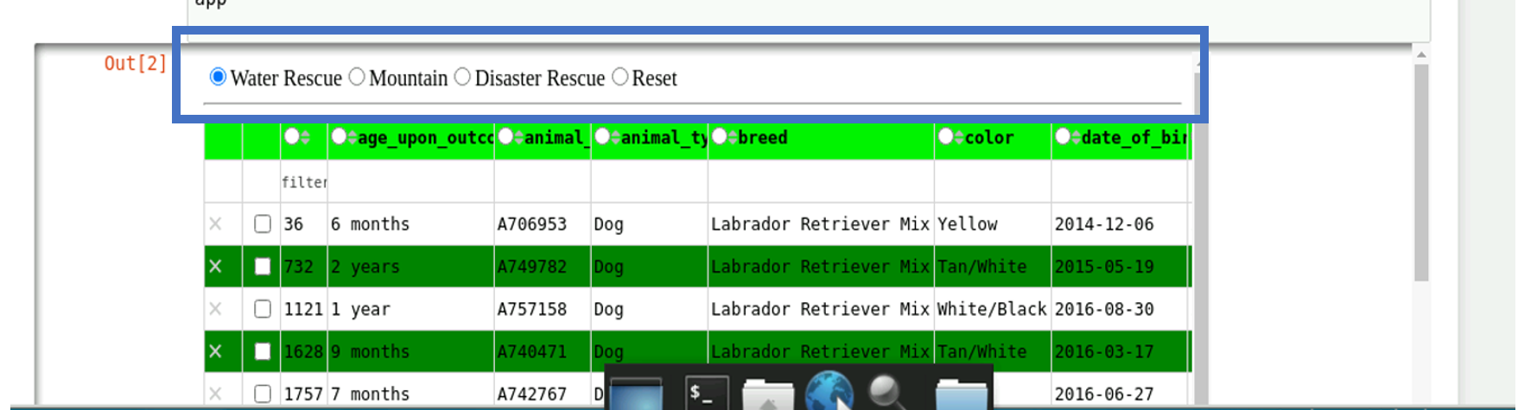

Below you see the proper data portrayed for the specified animal that the user wishes to view as well as a geographic chart shown of said animal.

As you see below the chart will populate on a map showing the location and details of the inquired animal the user is wishing to view. This will help ensure that the users know the precise location of the animal.

Shown below is a visual representation of the data inquired about to show the user exactly what they’re looking for in a different view. Ideal for managing animal types, amounts, and more.

**Steps taken:**

1. Nothing was needed to complete this as they were all available via the Apporto VM. For individuals outside of that who would like to utilize this, it would be necessary that they have Jupyters Notebook and MongoDB.
2. Developing the proper visualization tools such as the Grazioso chart, data tables that include the animal’s personal information, and the map to populate the animal’s location on. Essentially building upon what I completed in Module 6.

**Dash:**

Overall, Dash was easy to utilize and find information on to navigate and learn it efficiently. It simplified everything extremely and helped with the overall visualization of everything.

**Challenges Encountered:**

I didn’t face too many challenges in this project, the hardest part was just ensuring I had the proper information needed to make everything correctly. Any issues I did have were easily resolved throughout the project.